Robotics Process Automation Design and Development (UiPath) – BCG701 Lab
Experiment No: 8
Title: Develop Excel automation in UiPath StudioX to demonstrate the following activities: Insert Rows, Delete Rows, Find First/Last Data Row, For Each Excel Row, Write Cell, Create Pivot Table, Save Excel File As, Save Excel File As PDF.

Aim: To develop an automation in UiPath StudioX that demonstrates Excel file automation by performing operations such as:
- Insert Rows
- Delete Rows
- Find First/Last Data Row
- For Each Excel Row
- Write Cell
- Create Pivot Table
- Save Excel File As
- Save Excel File As PDF

Theory:
- Insert Row: The Insert Rows activity allows you to add one or multiple rows to a defined range, sheet, or table.
- Delete Rows: The Delete Rows activity deletes one or multiple rows identified in a sheet, range, or table from a workbook.
- Find First/Last Data Row: The Find First/Last Data Row activity allows you to find the first and last row number containing data in a sheet, table, or range in a workbook.
- For Each Excel Row: The For Each Excel Row activity allows you to execute one or more activities against each row in a sheet, table, or range within the same workbook.
- Write Cell: The Write Cell activity allows you to write a value or a formula into a given cell in a worksheet.
- Create Pivot Table: The Create Pivot Table activity creates a pivot table that helps you organize, analyze, and summarize data. Additionally, the Create Pivot Table activity is accompanied by the Add Pivot Field child activity allowing you to add rows, columns, filters, or values to the new pivot table.
- Save Excel File As: The Save Excel File As activity allows you to save the referenced Excel file as a different Excel file type including .xlsx, .xlsb, .xlsm, and .xls.
- Save Excel File As PDF: The Save Excel File As PDF activity allows you to save the referenced Excel file or the Project Notebook as a PDF file.

Conduction:
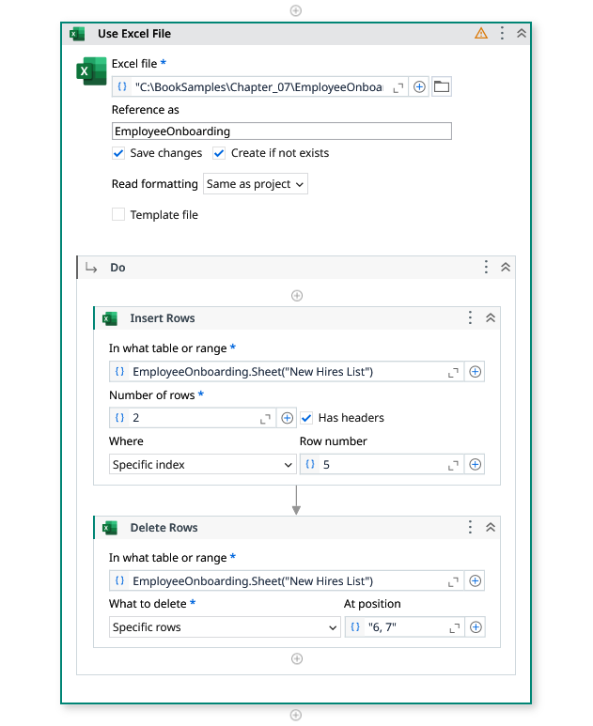

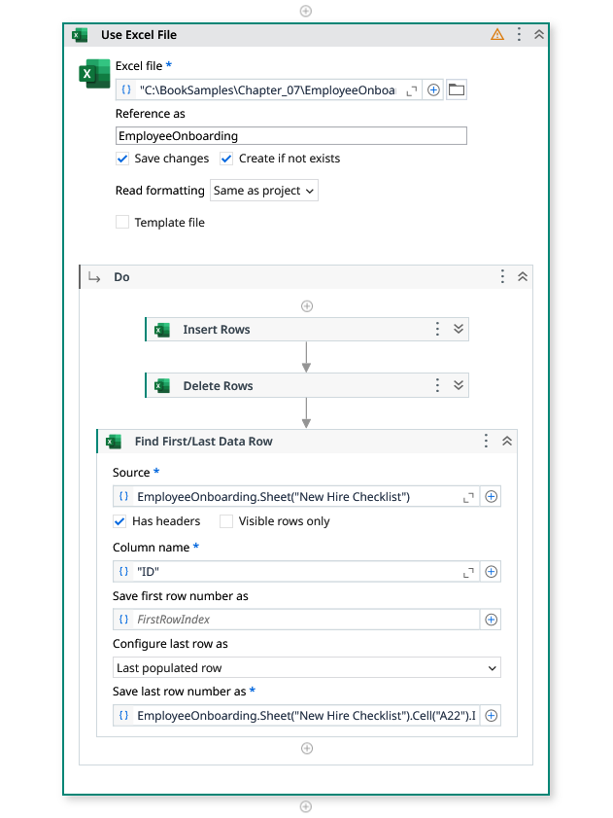

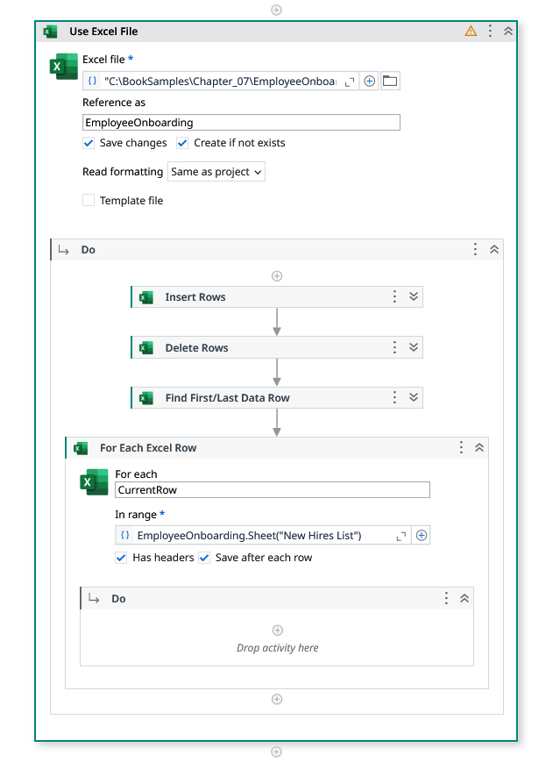

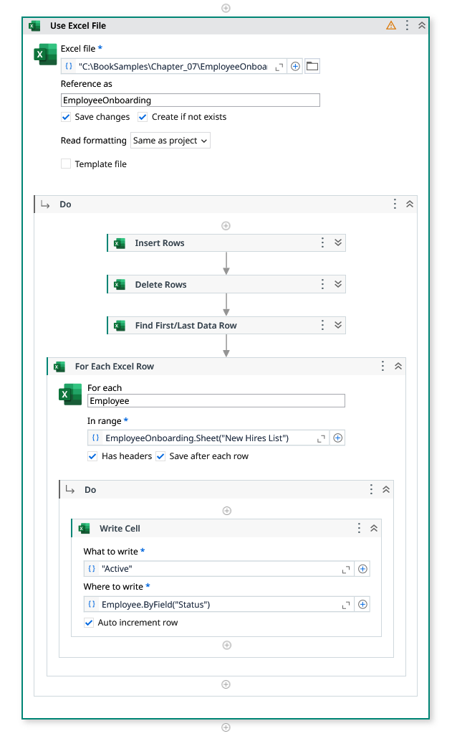
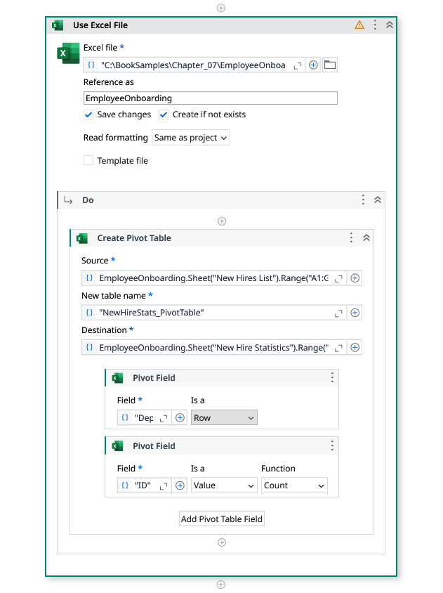

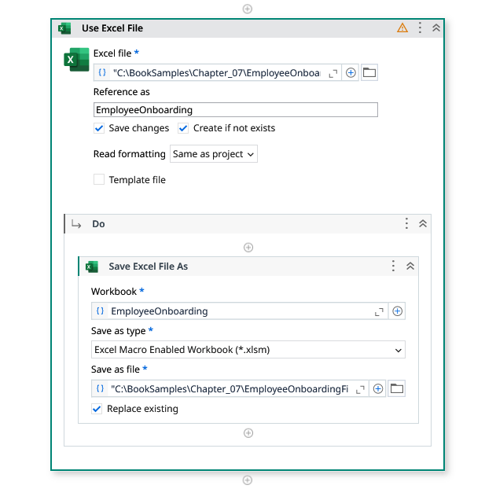

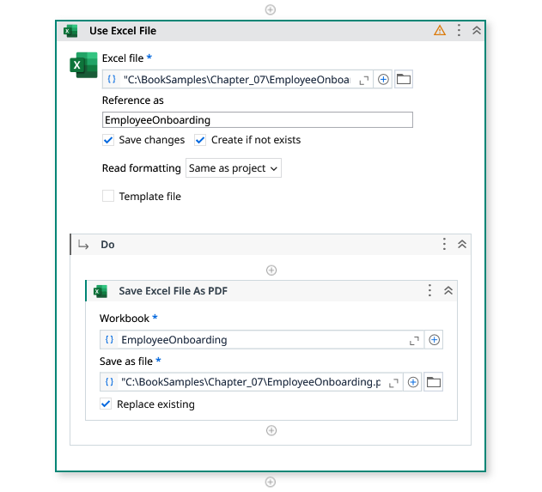

Output:
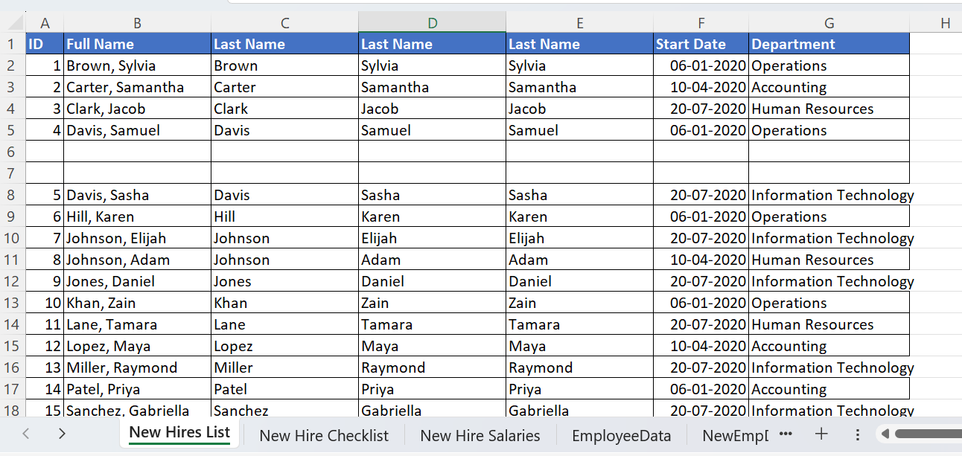
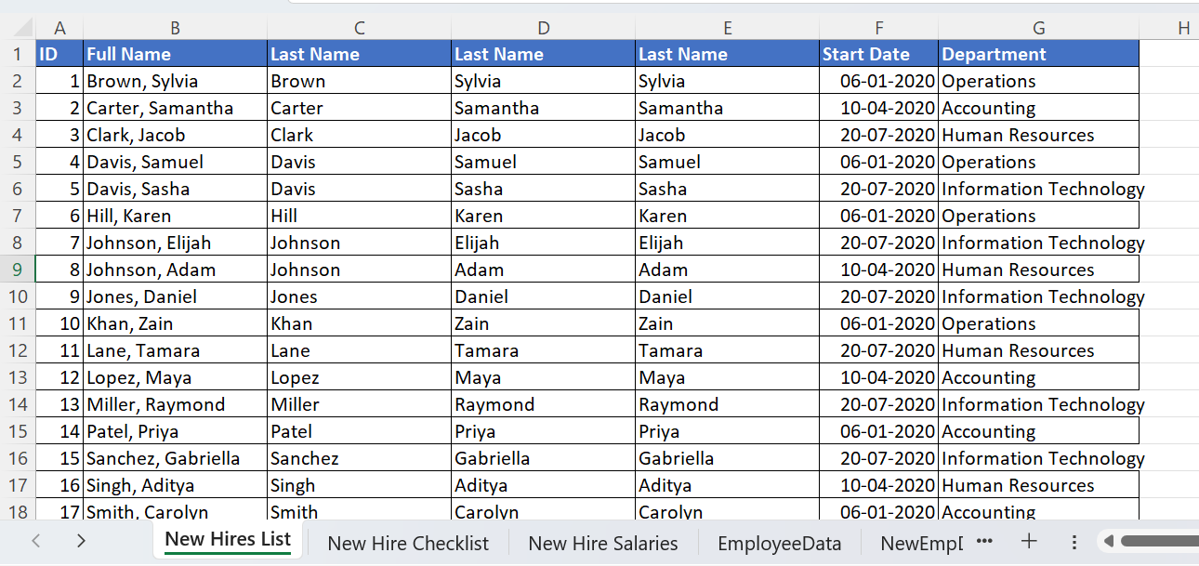

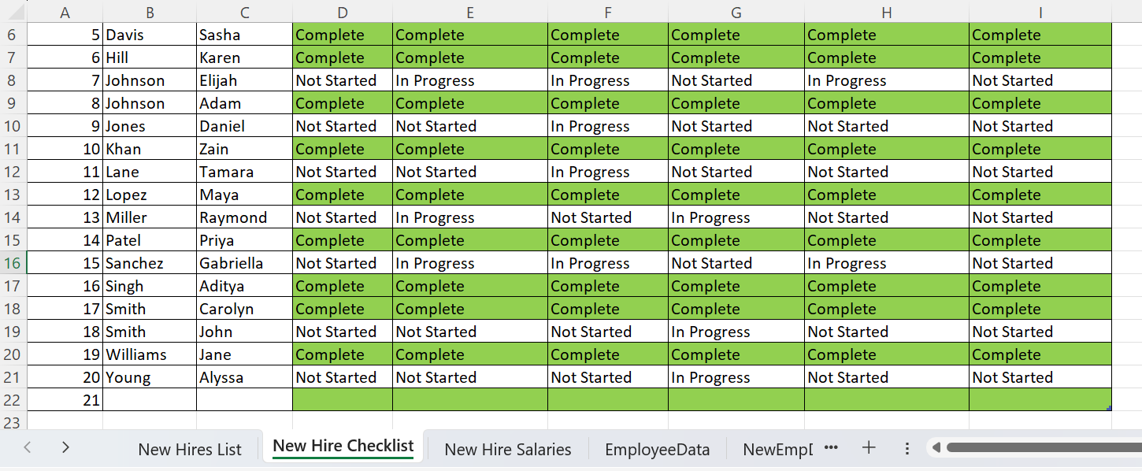

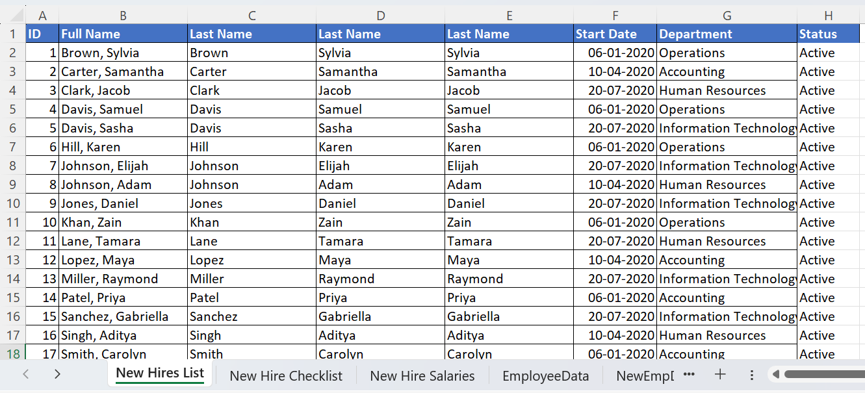

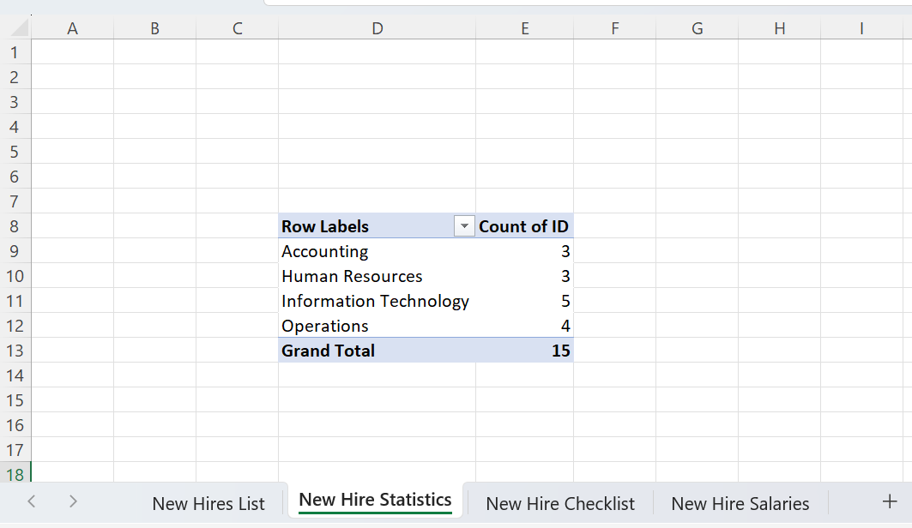

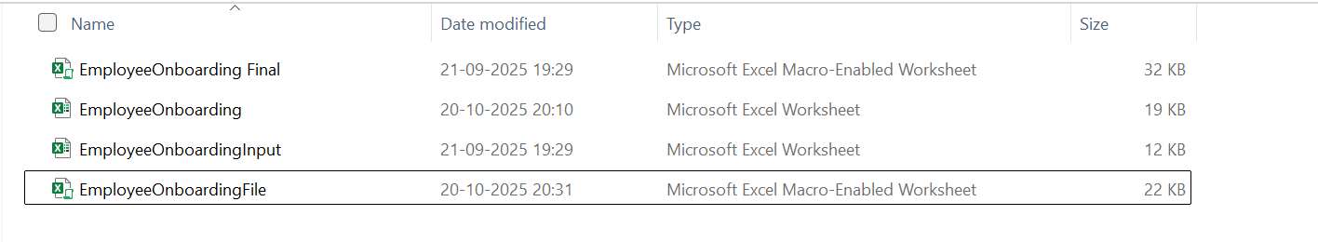
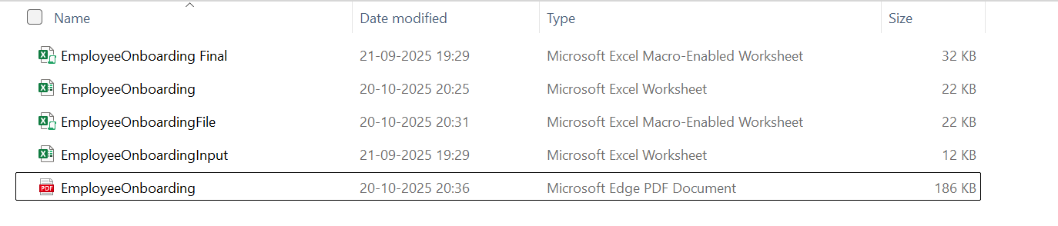

Observation and Results:
The following activities were successfully demonstrated in UiPath StudioX:
- Insert Rows
- Delete Rows
- Find First/Last Data Row
- For Each Excel Row
- Write Cell
- Create Pivot Table
- Save Excel File As
- Save Excel File As PDF
The output for the above-mentioned activities is verified.

Evaluation:
Evaluation Parameters | Maximum Marks | Obtained Marks
Conduction | 8
Record Writing | 4
Viva | 3
Total | 15

Signature of the Faculty in-charge with date:

